Title
Clinical Practice Guideline

Insert Service Name(s), Directorate and applicable Location(s):

Guideline Development Group

Guideline Programme Team

Approved by (NWIHP/IOG CAG)

Reference Number:

Version Number:

Publication Date:

Date for revision:

Electronic Location:

Version | Date Approved | Section numbers changed | Author
Cite this document as
Author 1, Author 2, Author 3, Author 4. National Clinical Practice Guideline: Assessment and Management of XXXXX. National Women and Infants Health Programme and The Institute of Obstetricians and Gynaecologists. Month/Year

Table of Contents

Algorithm (s) 1
Key Recommendations 2
CHAPTER 1: INITIATION 3
1.1 Purpose 3
1.2 Scope 3
1.3 Objective 3
1.4 Guideline development process 3
1.5 Stakeholder involvement 4
1.6 Disclosure of interests 4
1.7 Disclaimer 5
1.8 Use of language 6
CHAPTER 2: CLINICAL PRACTICE GUIDELINE 7
CHAPTER 3: DEVELOPMENT OF CLINICAL PRACTICE GUIDELINE 11
3.1 Literature search strategy 11
3.2 Appraisal of evidence 11
3.3 AGREE II process 11
3.4 Literature review 12
3.5 Grades of recommendation 12
3.6 Future research 12
CHAPTER 4: GOVERNANCE AND APPROVAL 14
4.1 Formal governance arrangements 14
4.2 Guideline development standards 14
4.3 Copyright/Permission sought (if applicable) 14
CHAPTER 5: COMMUNICATION AND DISSEMINATION 15
CHAPTER 6: IMPLEMENTATION 16
6.1 Implementation plan 16
6.2 Education plans required to implement the Guideline 16
6.3 Barriers and facilitators 16
6.4 Resources necessary to implement recommendations 17
CHAPTER 7: AUDIT AND EVALUATION 18
7.1 Introduction to audit 18
7.2 Auditable standards 18
7.3 Evaluation 18
CHAPTER 8: REVISION PLAN 19
8.1 Procedure for the update of the Guideline 19
8.2 Method for amending the Guideline 19
CHAPTER 9: REFERENCES 20
Reference list 20
Bibliography 21
Supporting Evidence 21
GLOSSARY (for the Purpose of this Guideline) 23
APPENDICES 1
Appendix 1 Expert Advisory Group Members 2021- 1
Appendix 2 Guideline Programme Process 4

Algorithm (s)

Key Recommendations

CHAPTER 1: INITIATION

The National Clinical Effectiveness Committee (NCEC) and Health Information and Quality Authority (HIQA) define clinical guidelines as systematically developed statements, based on a thorough evaluation of the evidence, to assist practitioner and patient decisions about appropriate healthcare for specific clinical circumstances, across the entire clinical spectrum.

Purpose

The purpose of this Guideline was to develop and provide a comprehensive evidence-based guidance for …….

Scope

Target Users
The Guideline is a resource or all clinicians working in ………

Healthcare staff, doctors, advanced midwifery practitioner, midwives, nurses, health and social care professionals involved in the care of …………………

Target Population

A clear description of the population (i.e. patients, public, etc.) covered by a PPPG document should be provided. The age range, sex, clinical description, and co-morbidity may be provided

Objective

To provide evidence based recommendations for the care of women with/during/post……………… as well as promoting a standardised approach nationally across all maternity units………….

1.4 Guideline development process

The Guideline Developers agreed to undertake this work under the direction of the Guideline Programme Team (GPT). An Expert Advisory Group (EAG) was commissioned by the GPT. Their role was to critically review the Guideline prior to submission to the National Women and Infants Health Programme (NWIHP) for final approval.

See Appendix 1 for EAG group membership and Appendix 2 for Guideline development flowchart.

*Guideline Developers to insert details of the writing group members here*
List or Table may be used

1.5 Stakeholder involvement

Stakeholders are people who have a common interest in improving health services. This includes persons that are responsible for delivering and those who receive services related to the clinical Guideline.

The following additional stakeholders were consulted in regard to this Guideline.

The Guideline Development Group was made up of XXXs with a special interest in XXX.

In addition XX (name, role, and organisation) was asked to review the guideline draft

The Expert Advisory Group has representatives from XXX as well as XXX. Also included in the membership are professionals from the areas of X, Y, Z

**Guideline developers to add to this section**

Ensure stakeholders and/or reviewers have given permission to be named in the guideline.

Disclosure of interests

Guideline developers and reviewers bring a range of experiences and perspectives to the work of the national Guideline Programme. It is likely that both Guideline developers and stakeholders/reviewers will have a variety of interests, arising from different contexts and activities done in a professional or personal capacity. These can include employment and other sources of income, speaking engagements, publications and research, and membership of professional or voluntary organisations. The involvement of individuals with relevant content expertise is essential for enhancing the value of Guideline recommendations, but these individuals may also have interests that can lead to conflicts of interest, as may peer reviewers, patient representatives and researchers.
All interests should be declared if, in the view of a reasonable person, they are relevant, or could be perceived to be relevant, to the work of the Clinical Practice Guideline in question. Declaring an interest does not mean there is a conflict of interest.

It is important that interests are openly declared so they can be appropriately managed. Conflicts of interest can bias recommendations and ultimately be harmful to women and the health system. Disclosures of interests and appropriate management of conflicts of interest, when identified, are therefore essential to producing high-quality, credible health guidelines.
The Guidelines International Network (GIN), a global network of Guideline developers that aims to promote best practices in the development of high-quality guidelines, developed a set of 9 principles to provide guidance on how financial and non-financial conflicts of interest should be both disclosed and managed. It is recommended that Guideline developers follow the GIN principles.
For this National Clinical Practice Guideline, all Guideline developers are asked to complete a conflict of interest declaration form. The response to declared interests will be managed by the Guideline programme team, in accordance with GIN principles. Conflicts of interest may be reported in the published Guideline and declarations of interest can be made available.

1.7 Disclaimer

These guidelines have been prepared to promote and facilitate standardisation and consistency of good clinical practice, using a multidisciplinary approach. Information in this Guideline is current at the time of publication.

The ultimate judgement regarding a particular clinical procedure or treatment plan must be made by the Clinician in light of clinical data presented by the woman and the diagnostic and treatment options available. Clinical material offered in this Guideline does not replace or remove clinical judgment or the professional care and duty necessary for each specific woman. Clinical care carried out in accordance with this Guideline should be provided within the context of locally available resources and expertise.

This Guideline does not address all elements of standard practice and assumes that individual clinicians are responsible for:

- Discussing care with women in an environment that is appropriate and which enables respectful confidential discussion. This includes the use of interpreter services where necessary
- Advising women of their choices and ensure informed consent is obtained
- Provide care with professional scope of practice, meeting all legislative requirements and maintaining standards of professional conduct
- Applying standard precautions and additional precautions, as necessary, when delivering care
- Documenting all care in accordance with local and mandatory requirements

1.8 Use of language

Within this guidance we use the terms 'woman' and 'women's health'. However, it is important to acknowledge that people who do not identify as cis-gender women are excluded from this descriptor, including people who identify as transgender, gender diverse and gender non-binary. While there has been a trend to remove the word ‘woman/women’ and use ‘gender neutral’ language in policy and practice in relation to women’s reproductive health and wellbeing, there is no evidence base to inform this change. We also appreciate that there are risks to desexing language when describing female reproduction .
Services and delivery of care must be appropriate, inclusive and sensitive to the needs of people whose gender identity does not align with the sex they were assigned at birth. This includes training and education regarding diverse pathways to pregnancy and the use of practices which affirm the sexual and gender identities of all people using Obstetrics and Gynaecology services. Finally, all those using maternal and reproductive health care and services should receive individualised, respectful care including use of the gender nouns and pronouns they prefer.⁷
Language use is key to effectively communicate options, recommendations, and respectfully accept a woman’s fully informed decision. With this in mind, the use of birth is preferable to the term delivery in all circumstances and is used consistently where possible throughout the guidelines. It is acknowledged that in some circumstances (e.g., in the case of a medically indicated intervention or surgery) and in some contexts, substituting with the term delivery is considered appropriate and this term may be used instead.

CHAPTER 2: CLINICAL PRACTICE GUIDELINE

In this chapter, we ask that you cover all of the aspects of your Guideline topic that pertain to clinical practice. The layout of this chapter should be systematic, begin with the initial clinical steps you would recommend and work your way through to the final step.

Background

A brief background should provide the reader with an overview of the general topic. For examples, include definitions, prevalence, risk factors, and significance.

Recommendations relevant to this Guideline can also be found in:
GDG to list/reference relevant national guidelines
- National clinical Guideline: XXX
- National clinical Guideline: XXX
- National clinical Guideline: XXX

*Insert Section heading if you wish e.g. Clinical Questions; Section 1- Antenatal Care

Introduction

A short introduction should inform the reader what is going to be discussed; for example, investigations required or treatment options.

The clinical question will assist to focus on one area at a time. Multiple questions may be addressed in one section if necessary.

Clinical Question 2.1: What are the essential steps when first assessing a woman that presents with xxxxxx?

Evidence Statement

The Evidence statement is the section where the developer describes what the clinical evidence supports. It is in this section that the developer will refer to all relevant publications that support their recommendations.

Examples of text include

The evidence to support this recommendation is largely derived from journals and textbooks as well as from research exploring clinicians’ knowledge and decision-making in the area of xxxxxxxxxxx.

To inform the development of this Guideline, existing policies and recently published international documents on xxxxxxxxxx were also reviewed.

The following recommendations are based on………

*Insert supporting references in this section*

Clinical Practice **Guideline developer to add to this section**

Outline clearly in a stepwise fashion the pathway of care for the woman.

Each phase of the woman’s care needs to be addressed: for example Out-patient care (if applicable), Antenatal Care (if applicable), Intrapartum Care (if applicable), Postnatal Care (if applicable) and any other relevant time point.

Recommendations
- *Recommendations are to be numbered sequentially throughout the document

Introduction (this is only needed again if using ‘sections’ and starting a new section otherwise go directly to next question)

The clinical question will assist to focus on one area at a time.

Clinical Question 2.2: What is the recommended management pathway in a woman that presents with xxxx?

Evidence Statement

The Evidence statement is the section where the developer describes what the clinical evidence supports. It is in this section that the developer will refer to all relevant publications that support their recommendations.

Examples of text include

The evidence to support this recommendation is largely derived from journals and textbooks as well as from research exploring clinicians’ knowledge and decision-making in the area of xxxxxxxxxxx.

To inform the development of this Guideline, existing policies and recently published international documents on xxxxxxxxxx were also reviewed.

The following recommendations are based on………

*Insert supporting references in this section*

Clinical Practice **Guideline developer to add to this section**

Outline clearly in a stepwise fashion the pathway of care for the woman. Each phase of the woman’s care needs to be addressed, Out-patient care (if applicable), Antenatal Care (if applicable), Intrapartum Care (if applicable), Postnatal Care (if applicable) and any other relevant time point.
Recommendations

Clinical Question 2.3:

Evidence Statement

The Evidence statement is the section where the developer describes what the clinical evidence supports. It is in this section that the developer will refer to all relevant publications that support their recommendations.

Examples of text include

The evidence to support this recommendation is largely derived from journals and textbooks as well as from research exploring clinicians’ knowledge and decision-making in the area of xxxxxxxxxxx.

To inform the development of this Guideline, existing policies and recently published international documents on xxxxxxxxxx were also reviewed.

The following recommendations are based on………

*Insert supporting references in this section*

Clinical Practice **Guideline developer to add to this section**

Outline clearly in a stepwise fashion the pathway of care for the woman. Each phase of the woman’s care needs to be addressed; for example: Out-patient care (if applicable), Antenatal Care (if applicable), Intrapartum Care (if applicable), Postnatal Care (if applicable) and any other relevant time point.

Recommendations

CHAPTER 3: DEVELOPMENT OF CLINICAL PRACTICE GUIDELINE

3.1 Literature search strategy

A comprehensive literature review was undertaken which included national and international publications.

The following should be included: databases searched, search terms used, search limits, inclusion and exclusion criteria, time periods searched*

*Refer to the Guideline Developer Information sheet for guidance

3.2 Appraisal of evidence

*Refer to the Guideline Developer Information sheet for guidance *

*GDG may wish to add to this section*

Following a comprehensive literature review the quality, validity and relevance of the evidence gathered were critically appraised by the Guideline developers under the following headings:

- Study design
- Relevance of primary and secondary outcomes
- Consistency of results across studies
- Magnitude of benefit versus magnitude of harm
- Applicability to practice context

A number of evidence-based recommendations for management of xxxxx were agreed upon. They have been adapted to reflect care in the Irish healthcare setting.

3.3 AGREE II process

While being developed, the Guideline was assessed using the AGREE II checklist (Appendix X) as recommended by the Department of Health in the ‘How to Develop a National Clinical Guideline: a manual for guideline developers', 2019.

The purpose of AGREE II is to provide a framework to:
- Assess the quality of guidelines;
- Provide a methodological strategy for the development of guidelines; and
- Inform what information and how information ought to be reported in guidelines

3.4 Literature review

Details of supportive evidence-based literature for this Guideline are reported in chapter two.

In this section (3.4) guideline developers may include:

• What was the role of each developer in the literature review process
• Who conducted the review of the literature
- When was the search performed, include dates
• Who reviewed the final documents selected
• What evidence is available to answer the clinical questions
• What is the quality of evidence
• Is the evidence applicable to the Irish setting
• Why literature was used or omitted

*Refer to the Guideline Developer Information sheet for guidance *

3.5 Grades of recommendation

GRADE offers a transparent and structured process for developing and presenting evidence summaries and for carrying out the steps involved in developing recommendations.

While we acknowledge that for this particular work an extensive GRADE approach is not possible, we have used the suggested language set out in the GRADE table when making recommendations. (Appendix X)

3.6 Future research

**Guideline developer to add to this section**

An important outcome of the Guideline development process is in highlighting gaps in the evidence base.

The questions of relevance to this Guideline include;

CHAPTER 4: GOVERNANCE AND APPROVAL

4.1 Formal governance arrangements

This Guideline was written by the Guideline developers under the direction of the Guideline Programme Team (GPT). An Expert Advisory Group was formed to review the Guideline prior to submission for final approval with the National Women and Infants Health Programme. The roles and responsibilities of the members of each group and their process were clearly outlined and agreed.

4.2 Guideline development standards

This Guideline was developed by the Guideline Developer Group (GDG) within the overall template of the HSE National Framework for developing Policies, Procedures, Protocols and Guidelines (2016) (Appendix X) and under supervision of the Guideline Programme Team.

A review was conducted by a group of experts, specialists and advocates (the EAG) prior to approval by the Clinical Advisory Group (CAG) of the National Women and Infants Health Programme (NWIHP) with final sign off for publication by CAG Co-Chairs, the Clinical Director of NWIHP and the Chair of the IOG.
See appendix xx for list of CAG members.

4.3 Copyright/Permission sought (if applicable)

CHAPTER 5: COMMUNICATION AND DISSEMINATION

A communication and dissemination plan for this Guideline has been developed by the GPT and endorsed by NWIHP.

Effective ongoing clear communication is essential in explaining why the Guideline is necessary and securing continued buy-in. It provides an opportunity to instil motivation within staff, helps overcome resistance to change and gives an opportunity for feedback.

The Clinical Guideline will be circulated and disseminated through the Guideline Programme Team as well as through the professional networks who participated in developing and reviewing the document.

Senior management within the maternity units are responsible for the appropriate dissemination of new and updated guidelines. Local hospital groups including Guideline committees are also instrumental in the circulation of new and updated guidelines and promoting their use in the relevant clinical settings.

The HSE will make this Guideline available to all employees through standard networks as well as storing it in the online PPPG repository. Electronic versions available on the NWIHP https://www.hse.ie/eng/about/who/acute-hospitals-division/woman-infants/clinical-guidelines/ and RCPI websites (https://www.rcpi.ie/faculties/obstetricians-and-gynaecologists/national-clinical-guidelines-in-obstetrics-and-gynaecology/) and other communication means can be used to maximise distribution. The NWIHP website will also provide a training webinar introducing each Guideline and where relevant a downloadable version of the recommended algorithm will be available.

In the case of this Guideline…
**Guideline developer may add to this section**

CHAPTER 6: IMPLEMENTATION

6.1 Implementation plan

Implementation was considered at the beginning, and throughout the Guideline development process. The local multidisciplinary clinical team, senior executive and clinical management in each maternity and gynaecology unit are ultimately responsible for the appropriate structured adoption and implementation of the Guideline within their area of responsibility. They must ensure that all relevant personnel under their supervision have read and understood the Guideline and monitor both its effectiveness and adoption.

Within each site, local multidisciplinary teams are responsible for the clinical implementation of Guideline recommendations, and ensuring that their local clinical practices and processes reflect and are aligned with the Guideline recommendations

In the case of this Guideline………

The following have been put in place to help facilitate the implementation of this Guideline.

- Quick Summary Document (QSD) for clinical staff (includes key recommendations, auditable standards, algorithms and recommended reading)
- Clinical Guideline mobile application
- Plain language summary

**Guideline developer may add to this section**

6.2 Education plans required to implement the Guideline

It is acknowledged that this Guideline should be complemented by ongoing education, training and assessment where required.

This Guideline’s education plan includes……

**Guideline developer may add to this section**

6.3 Barriers and facilitators

To ensure successful implementation of guidelines, it is first necessary to look at potential barriers and facilitators. Taking these into account when developing the implementation plan should improve levels of support from relevant users. (DOH 2018, 2019)

Barriers may be categorised as internal (specific to the Guideline itself) or external (specific to the clinical environment).

The Guideline Development Group has aimed to address any internal barriers during the development of this Guideline.

*GDG may include examples of internal barriers*-

Potential external barriers include:
- Structural factors (e.g. budget or service redesign)
- Organisational factors (e.g. lack of facilities or equipment)
- Individual factors (e.g. knowledge, skills, training)
- Woman’s perceptions

In the case of this Guideline it will be necessary to examine possible barriers and consider implementation strategies to address them. By example, this may include discussion with relevant management groups with regards budgetary impact or providing training to the relevant staff.

In the case of this Guideline………

**Guideline developer may wish to add to this section**

6.4 Resources necessary to implement recommendations

**Guideline developer may add to this section**

The implementation of this Guideline should be undertaken as part of the quality improvement of each hospital. Hospitals should review existing service provision against this Guideline, identifying necessary resources required to implement the recommendations in this Guideline.

In the case of this Guideline……..

CHAPTER 7: AUDIT AND EVALUATION

7.1 Introduction to audit

It is important that both implementation of the Guideline and its influence on outcomes are audited to ensure that this Guideline positively impacts on the care of the woman. Institutions and health professionals are encouraged to develop and undertake regular audits of Guideline implementation. Personnel tasked with the job of conducting the audit should be identified on receipt of the most recent version of the Guideline.

**Guideline developer to add to this section**

7.2 Auditable standards

Audit using the key recommendations as indicators should be undertaken to identify where improvements are required and to enable changes as necessary. Audit should also be undertaken to provide evidence of continuous quality improvement initiatives.

*Guideline developers are therefore asked to set auditable standards for their guideline. These are the standards by which implementation of recommendations can be evaluated within and across hospitals.*

Auditable standards for this Guideline include:

*Guideline Developers should also suggest audit criteria; this could include descriptions on how criteria are measured, to allow for assessment of guideline implementation and meaningful comparison of performance across different settings*

7.3 Evaluation

Evaluation is defined as a formal process to determine the extent to which the planned or desired outcomes of an intervention are achieved.

Implementation of this Guideline will be audited periodically at national level, with standards for this set by the NWIHP. Evaluation of the auditable standards should also be undertaken locally by senior hospital clinical management to support implementation.

CHAPTER 8: REVISION PLAN

8.1 Procedure for the update of the Guideline

It may be a requirement to amend, update or revise this Guideline as new evidence emerges. This Guideline will be reviewed at national level every three years, or earlier if circumstances require it, and updated accordingly.

The Guideline Development Group will be asked to review the literature and recent evidence to determine if changes are to be made to the existing Guideline. If the Guideline Development Group are unavailable, the GPT along with the NWIHP senior management team will select a suitable expert to replace them.

If there are no amendments required to the Guideline following the revision date, the detail on the revision tracking box must still be updated which will be a new version number and date.
The recommendations set out in this Guideline remain valid until a review has been completed.

8.2 Method for amending the Guideline

As new evidence become available it is inevitable that Guideline recommendations will fall behind current evidence based clinical practice. It is essential that clinical guidelines are reviewed and updated with new evidence as it becomes available.

In order to request a review of this Guideline one of the following criteria must be met:

- 3 years since the Guideline was published
- 3 years since last review was conducted
- Update required as a result of new evidence

Correspondence requesting a review of the Guideline should be submitted to the National Women and Infants Health Programme. Any such requests should be dealt with in a timely manner.

CHAPTER 9: REFERENCES

Reference list

**Guideline developer to add to this section**

Bibliography

**Guideline developer to add to this section**

Health Information Quality Authority (2012). National Standards for Safer Better Healthcare [Internet]. Available from: https://www.hiqa.ie/reports-and-publications/standard/national-standards-safer-better-healthcare

Scottish Intercollegiate Guidelines Network (SIGN). A guideline developer’s handbook. Edinburgh: SIGN; 2019. (SIGN publication no. 50). [November 2019]. Available from URL: http://www.sign.ac.uk

Society of Maternal-Fetal Medicine. SMFM Clinical Practice Guidelines Development Process [Internet]. Available from: https://www.smfm.org/publications

Department of Health (2018). NCEC Implementation Guide and Toolkit. Available at: https://health.gov.ie/national-patient-safety-office/ncec/

Department of Health (2019). How to develop a National Clinical Guideline. Available at: https://www.gov.ie/en/collection/cd41ac-clinical-effectiveness-resources-and-learning/

Department of Health (2015). NCEC Standards for Clinical Practice Guidance. Available at: https://www.nmbi.ie/NMBI/media/NMBI/Forms/standards-for-clinical-practice-guidance-ncec.pdf

Health Service Executive (2016). National Framework for developing Policies, Procedures, Protocols and Guidelines (PPPGs). Available from: https://www.hse.ie/eng/about/who/qid/nationalframeworkdevelopingpolicies/

Health Service Executive (2019). National Review of Clinical Audit. Available from: https://www.hse.ie/eng/services/publications/national-review-of-clinical-audit-report-2019.pdf

National Clinical Effectiveness Committee (NCEC) and Health Information and Quality Authority (HIQA) (2015) National quality assurance criteria for clinical guidelines. Version 2. Dublin: NCEC and HIQA. https://www.hiqa.ie/sites/default/files/2017-01/National-Quality-Assurance-Criteria.pdf

Health Service Executive (2022), National Centre for Clinical Audit Nomenclature - Glossary of Terms, National Quality and Patient Safety Directorate. Available from: https://www.hse.ie/eng/about/who/nqpsd/ncca/

Supporting Evidence
GRADE: http://www.gradeworkinggroup.org/
AGREE: http://www.agreetrust.org/agree-ii/
HSE: https://www.hse.ie/eng/about/who/qid/use-of-improvement-methods/nationalframeworkdevelopingpolicies/

GLOSSARY (for the Purpose of this Guideline)

AGREE Appraisal of Guidelines for Research and Evaluation
ACOG American College of Obstetricians and Gynaecologists
CAG Clinical Advisory Group
EAG Expert Advisory Group
GPT Guideline Programme Team
GRADE Grading of Recommendations, Assessments, Developments and Evaluations
HIQA Health Information and Quality Authority
HSE Health Service Executive
IOG Institute of Obstetricians and Gynaecologists
FIGO International Federation of Gynaecology and Obstetrics
NICE The National Institute for Health and Care Excellence
NCEC National Clinical Effectiveness Committee
NWIHP National Women and Infants Health Programme
PPPG Policy, Procedures, Protocols and Guidelines
RCOG Royal College of Obstetricians and Gynaecologists
RCPI Royal College of Physicians of Ireland

APPENDICES

Appendix 1 Expert Advisory Group Members 2021-

Member | Profession | Location
Dr Mairead Butler | Consultant Obstetrician and Gynaecologist | University Hospital Waterford
Dr Nicholas Barrett | Consultant Anaesthesiologist, Lead for Obstetric Anaesthesiology services | Limerick University Hospital
Dr Venita Broderick | Consultant Obstetrician and Gynaecologist | National Maternity Hospital Dublin
Ms Siobhan Canny | Group Director of Midwifery | Saolta University Health Care Group
Ms Triona Cowman | Director of the Centre for Midwifery Education | Centre for Midwifery Education, Coombe Women & Infants University Hospital
Ms Marie Culliton | Lab Manager/Chief Medical Scientist | National Maternity Hospital Dublin
Ms Niamh Connolly-Coyne And  Ms Mandy Daly | Board of Directors Members  (Shared nomination) | Irish Neonatal Health Alliance
Ms Sinéad Curran | Dietician Manager | National Maternity Hospital
Dr Niamh Conlon | Consultant Histopathologist | Cork University Hospital
Ms Georgina Cruise | National Manager | Patient Advocacy Service
Dr Orla Donohoe | Specialist Registrar, Obstetrics and Gynaecology and SWEC Fellow | St George Hospital, Sydney, Australia
Ms Alana Dineen | Senior Clinical Pharmacist | Cork University Maternity Hospital
Prof Maeve Eogan | Consultant Obstetrician and Gynaecologist  National Clinical Lead SATU (HSE) | Rotunda Hospital Dublin
Dr Brendan Fitzgerald | Consultant Perinatal Pathologist | Cork University Hospital
Dr Daniel Galvin | Specialist Registrar, Obstetrics and Gynaecology | Cork University Maternity Hospital
Ms Stacey Grealis | Patient Research Partner | Independent Living Movement Ireland
Ms Fiona Hanrahan | Director of Midwifery and Nursing | Rotunda Hospital Dublin
Ms Laura Harrington | Principal Medical Social Worker | National Maternity Hospital Dublin
Ms Marita Hennessy | Post-Doctoral Researcher | Pregnancy Loss Research Group,  INFANT Centre,  University College Cork
Ms Caroline Joyce | Principal Clinical Biochemist  PhD Candidate | Cork University Hospital  University College Cork
Dr Chaitra Jairaj | Consultant Perinatal Psychiatrist | Coombe Women & Infants University Hospital, Dublin  Midland Regional Hospital Portlaoise
Dr Cathy Monteith | Consultant Obstetrician and Gynaecologist | Our Lady of Lourdes Hospital Drogheda
Prof John Murphy | Consultant Neonatologist  Clinical Lead for the National Clinical Programme for Paediatrics and Neonatology | National Women and Infants Health Programme
Ms Janet Murphy | Advanced Midwifery Practitioner | University Hospital Waterford
Dr Jill Mitchell | Specialist Registrar, Obstetrics and Gynaecology | Cork University Maternity Hospital
Dr Aisling McDonnell | Specialist Registrar, Obstetrics and Gynaecology | Mater Misericordiae University Hospital Dublin
Dr Ciara McCarthy | General Practitioner  ICGP and NWIHP Women’s Health Lead | Irish College of General Practitioners
Ms Orla McCarthy | Clinical Specialist Physiotherapist in Pelvic Health | Cork University Maternity Hospital
Dr Donough J. O’Donovan | Director Neonatal Intensive Care Unit  Consultant Neonatologist / Paediatrician | University College Hospital Galway
Mr Fergal O’ Shaughnessy  And  Dr Brian Cleary  (Shared nomination) | Senior Pharmacist, Honorary Lecturer  And  Chief Pharmacist, Honorary Clinical Associate Professor and Medications Lead, Maternal & Newborn Clinical Management System | Rotunda Hospital Dublin  Royal College of Surgeons in Ireland
Dr Gillian Ryan | Consultant Obstetrician and Gynaecologist | University Hospital Galway
Prof Valerie Smith | Chair of Midwifery | University College Dublin
Ms Nora Vallejo | Advanced Midwife Practitioner | Coombe Women & Infants University Hospital, Dublin
Member 2021-2023 | Profession | Location
Dr Katherine Astbury | Consultant Obstetrician and Gynaecologist | University Hospital Galway
Dr Richard Duffy | Consultant Perinatal Psychiatrist | Rotunda Hospital Dublin
Ms Clare Farrell | Physiotherapy Manager | Coombe Women & Infants University Hospital, Dublin
Ms Marie Finn | Medical Social Work Counsellor | Saolta University Health Care Group
Prof Declan Keane | Consultant Obstetrician, Gynaecologist, Professor of Obstetrics and Gynaecology | National Maternity Hospital Dublin, Royal College of Surgeons in Ireland
Ms Áine Kelly | Physiotherapy Manager | Coombe Women & Infants University Hospital, Dublin
Dr Fergus McCarthy | Consultant Obstetrician, Gynaecologist | Cork University Maternity Hospital, University College Cork
Dr Sarah Petch | Specialist Registrar, Obstetrics and Gynaecology | National Maternity Hospital Dublin
Ms Margaret Quigley | National Lead for Midwifery | Office of Nursing and Midwifery Services Director

Appendix 2 Guideline Programme Process

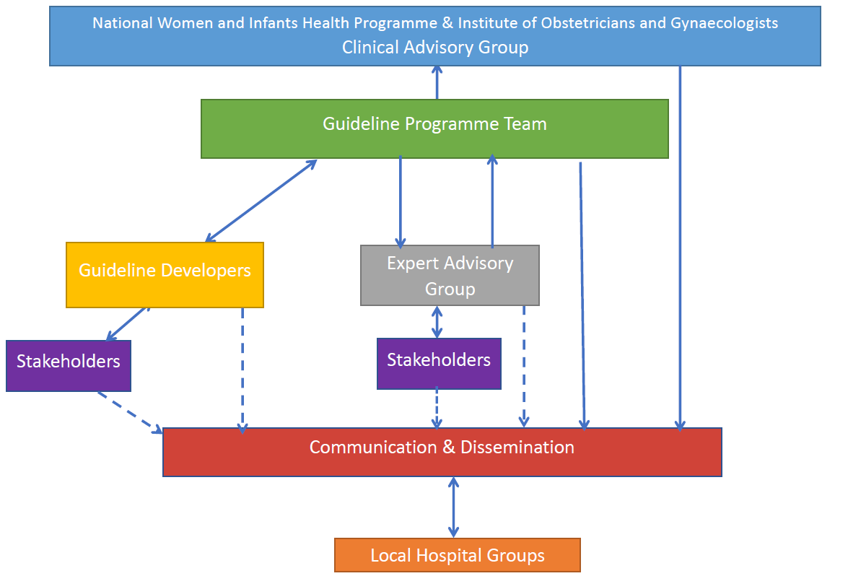
Appendix NWIHP/IOG CAG (2023-)

Dr Cliona Murphy (Chair, 2023-). Consultant Obstetrician and Gynaecologist, Coombe Women and Infants University Hospital. Clinical Director, National Women and Infants Health Programme.

Dr Sam Coulter-Smith (2023-). Consultant Obstetrician and Gynaecologist, Rotunda Hospital. Chair, Institute of Obstetricians and Gynaecologists.
Dr Venita Broderick (2024-). Clinical Lead Gynaecology, National Women and Infants Health Programme.
Dr Brian Cleary (2023-). Chief Pharmacist, Rotunda Hospital. Medications Lead, Maternal and Newborn Clinical Management System Project.
Angela Dunne (2023-). Director of Midwifery, National Women and Infants Health Programme.
Prof Seán Daly (2023-). Master, Consultant Obstetrician and Gynaecologist, Rotunda Hospital.
Prof Maeve Eogan (2023-). Consultant Obstetrician and Gynaecologist, Rotunda Hospital. Clinical Lead, Sexual Assault Treatment Units, National Women and Infants Health Programme.
Prof Richard Greene (2023-). Consultant Obstetrician and Gynaecologist, Cork University Maternity Hospital. Clinical Director, National Perinatal Epidemiology Centre, University College Cork.
Prof John Higgins (2023-). Cork University Maternity Hospital, Consultant Obstetrician and Gynaecologist, Clinical Director, Ireland South Women and Infants Directorate.
Prof Shane Higgins (2023-). Master, Consultant Obstetrician and Gynaecologist, National Maternity Hospital.
Dr Mendinaro Imcha (2023-). Clinical Director, Consultant Obstetrician and Gynaecologist, University Maternity Hospital Limerick.
Prof John Murphy (2023-). Clinical Lead Neonatology, National Women and Infants Health Programme.
Dr Aoife Mullaly (2023-). Consultant Obstetrician and Gynaecologist, Coombe Women and Infants University Hospital. Clinical Lead, Termination of Pregnancy Services, National Women and Infants Health Programme.
Prof John Morrison (2023-). Consultant Obstetrician and Gynaecologist, University Hospital Galway. Clinical Director, Saolta Maternity Directorate.
Kilian McGrane (2023-). Director, National Women and Infants Health Programme.
Dr Peter McKenna (2023-). Clinical Lead, Obstetric Event Support Team, National Women and Infants Health Programme.
Prof Keelin O’Donoghue (2023-). Consultant Obstetrician and Gynaecologist, Cork University Maternity Hospital. Clinical Lead, National Guidelines, National Women and Infants Health Programme.
Dr Suzanne O’Sullivan (2023-). Consultant Obstetrician and Gynaecologist, Cork University Maternity Hospital. Director of Education and Training, Obstetrics and Gynaecology, Institute of Obstetricians and Gynaecologists.
Prof Mike O’Connell (2023-). Master, Consultant Obstetrician and Gynaecologist, Coombe Women and Infants University Hospital.
Dr Vicky O’Dwyer (2023-). Consultant Obstetrician and Director of Gynaecology, Rotunda Hospital.
Prof Nóirín Russell (2023-). Consultant Obstetrician and Gynaecologist, Cork University Maternity Hospital. Clinical Director, Cervical Check.
Dr Carmen Regan (April 2024). Clinical Lead Obstetrics, National Women and Infants Health Programme.
Dr Orla Shiel (2024-). Consultant Obstetrician and Gynaecologist, National Maternity Hospital

Ms Clare Thompson (2023-). Consultant Gynaecological Oncologist, The Mater, Dublin.

Grade of recommendation | Clarity of risk/benefit​ | Quality of supporting evidence​ | Implications​ | Suggested Language​
1 A.​ Strong recommendation, high-quality evidence ​ | Benefits clearly outweigh risk and burdens, or vice versa​ | Consistent evidence from well-performed randomized, controlled trials or overwhelming evidence of some other form. Further research is unlikely to change our confidence in the estimate of benefit and risk ​ | Strong recommendations can apply to most patients in most circumstances without reservation. Clinicians should follow a strong recommendation unless a clear and compelling rationale for an alternative approach is present​ | We strongly recommend…. ​  We recommend that …should be​ performed/ administered…. ​  We recommend that …. is indicated/ beneficial/ effective….. ​
1 B.​ Strong recommendation, moderate-quality evidence ​ | Benefits clearly outweigh risk and burdens, or vice versa ​  ​ | Evidence from randomized, controlled trials with important limitations (inconsistent results, methodologic flaws, indirect or imprecise), or very strong evidence of some other research design. Further research (if performed) is likely to have an impact on our confidence in the estimate of benefit and risk and may change the estimate​ | Strong recommendation and applies to most patients. Clinicians should follow a strong recommendation unless a clear and compelling rationale for an alternative approach is present ​  ​ | We recommend…. ​  We recommend that … should be performed/ administered…. ​  We recommend that …. is (usually) indicated/ beneficial/ effective….
1 C.​ Strong recommendation, low-quality evidence ​ | Benefits appear to outweigh risk and burdens, or vice versa ​  ​ | Evidence from observational studies, unsystematic clinical experience, or from randomized, controlled trials with serious flaws. Any estimate of effect is uncertain​ | Strong recommendation that applies to most patients. Some of the evidence base supporting the recommendation is, however, of low quality​ | We recommend…. ​  We recommend that … should be performed/ administered…. ​  We recommend that …. Is (maybe) indicated/beneficial/ effective….
2A. ​Weak recommendation, high-quality evidence ​  ​ | Benefits closely balanced with risks and burdens ​  ​ | Consistent evidence from well-performed randomized, controlled trials or overwhelming evidence of some other form. Further research is unlikely to change our confidence in the estimate of benefit and risk​ | Weak recommendation: best action may differ depending on circumstances or patients or societal values​ | We suggest… ​ We suggest that …. may/might be reasonable... ​​
2B. ​Weak recommendation, moderate-quality evidence ​ | Benefits closely balanced with risks and burdens, some uncertainty in the estimates of benefits, risks and burdens ​ | Evidence from randomized, controlled trials with important limitations (inconsistent results, methodologic flaws, indirect or imprecise), or very strong evidence of some other research design. Further research (if performed) is likely to have an impact on our confidence in the estimate of benefit and risk and may change the estimate​ | Weak recommendation; alternative approaches likely to be better for some patients under some circumstances ​ | We suggest… ​  We suggest that …. may/might be reasonable... ​  ​
2C. ​Weak recommendation, low-quality evidence ​  ​ | Uncertainty in the estimates of benefits, risks, and burdens; benefits may be closely balanced with risks and burdens ​ | Evidence from observational studies, unsystematic clinical experience, or from randomized, controlled trials with serious flaws. Any estimate of effect is uncertain​ | Very weak recommendation: other alternatives may be equally reasonable. ​  ​ | We suggest… is an option ​  We suggest that …. may/might be reasonable.
Best practice ​  ​ | A recommendation that is sufficiently obvious that the desirable effects outweigh undesirable effects, despite the absence of direct evidence, such that the grading of​ evidence is unnecessary ​ | ​ | ​ | We recommend…. ​We recommend that … should be performed/ administered…. ​ We recommend that …. Is usually) indicated/ beneficial/ effective
Appendix Grades of Recommendation

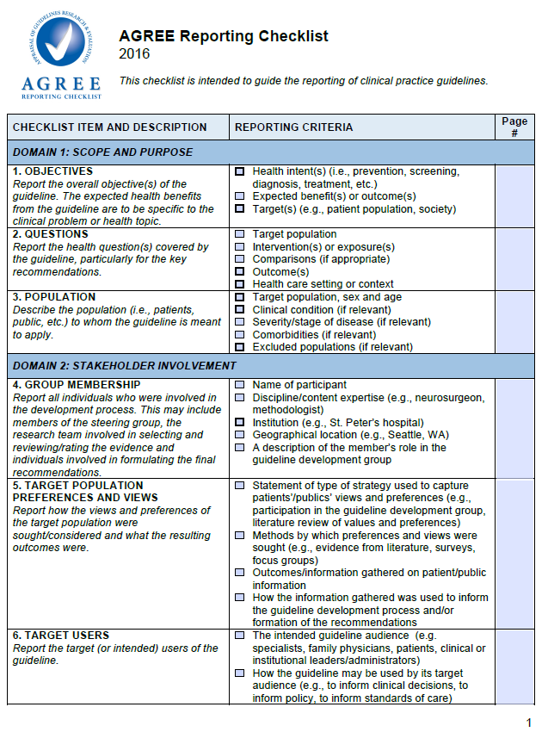
Appendix AGREE II checklist

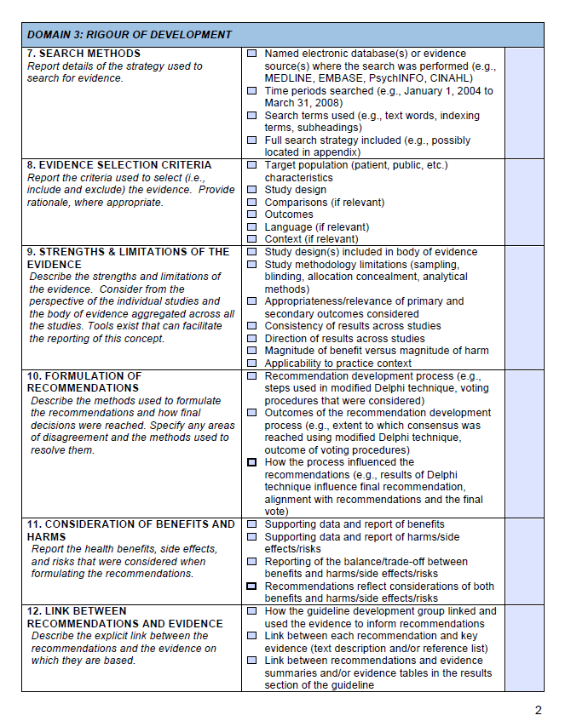

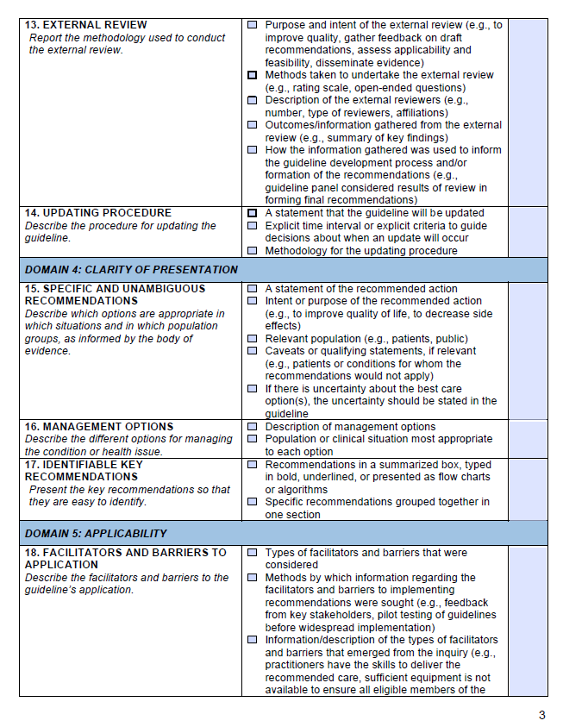

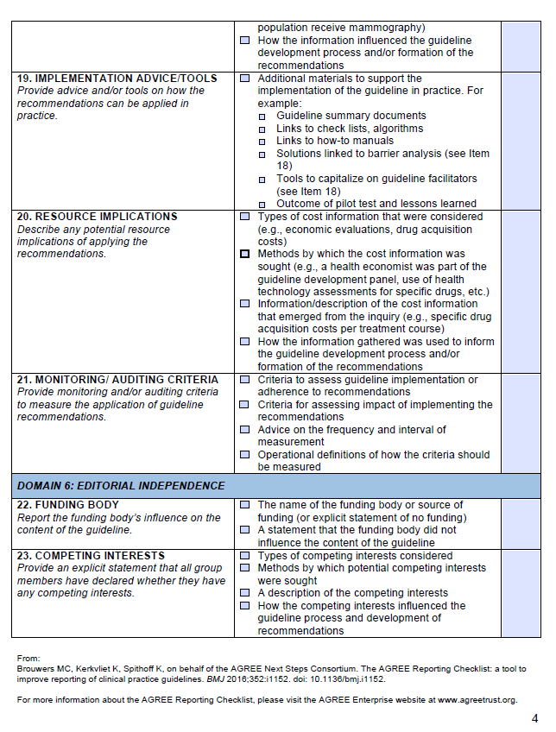

Appendix HSE PPPG checklist
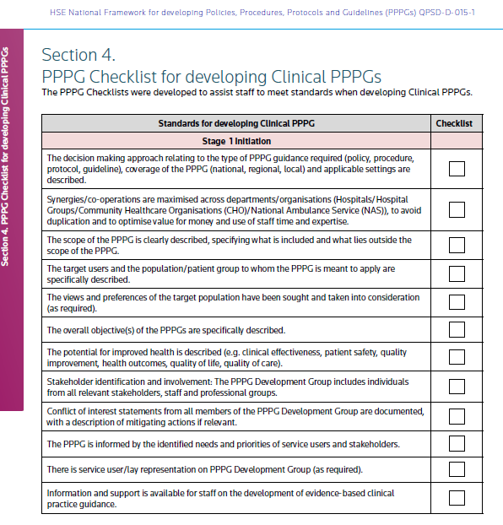
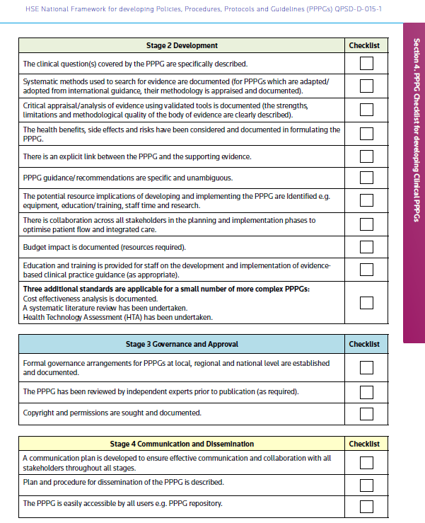

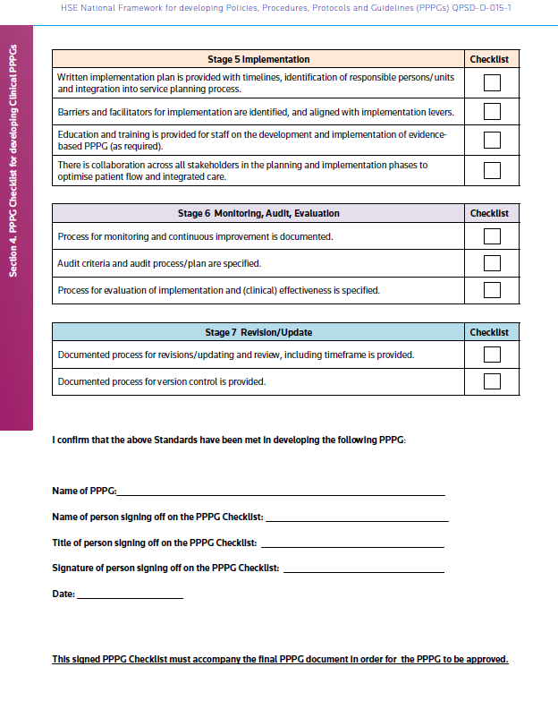

To view in full refer to website:
https://www.hse.ie/eng/about/who/qid/nationalframeworkdevelopingpolicies/

National Clinical Effectiveness Committee (NCEC) and Health Information and Quality Authority (HIQA) (2015) National quality assurance criteria for clinical guidelines. Version 2. Dublin: NCEC and HIQA. https://www.hiqa.ie/sites/default/files/2017-01/National-Quality-Assurance-Criteria.pdf
Nursing and Midwifery Board of Ireland (NMBI) (2018) Advanced Practice (Midwifery) Standards and Requirements. Dublin. www.nmbi.ie/NMBI/media/NMBI/Advanced-Practice-(Midwifery)-Standards-and-Requirements-2018-final.pdf
NICE (2019) Policy on declaring and managing interests for NICE advisory committees https://www.nice.org.uk/Media/Default/About/Who-we-are/Policies-and-procedures/declaration-of-interests-policy.pdf
Traversy G, Barnieh L, Akl EA, Allan GM, Brouwers M, Ganache I, Grundy Q, Guyatt GH, Kelsall D, Leng G, Moore A, Persaud N, Schünemann HJ, Straus S, Thombs BD, Rodin R, Tonelli M. CMAJ. 2021, 193(2):E49-E54. DOI: 10.1503/cmaj.200651 https://www.cmaj.ca/content/193/2/E49
Holger J. Schünemann, Lubna A. Al-Ansary, Frode Forland, et al.; for the Board of Trustees of the Guidelines International Network. Guidelines International Network: Principles for disclosure of interests and management of conflicts in guidelines. Ann Intern Med. 2015;163:548-553. doi:10.7326/M14-1885. https://www.acpjournals.org/doi/10.7326/m14-1885
Moseson H, Zazanis N, Goldberg E, et al. The Imperative for Transgender and Gender Nonbinary Inclusion. Obstet Gynecol. 2020;135(5):1059-1068. https://www.ncbi.nlm.nih.gov/pmc/articles/PMC7170432/
Council of Deans of Health. Midwifery Network position paper: use of sexed language. May 2023. https://www.councilofdeans.org.uk/2024/02/midwifery-network-position-paper-use-of-sexed-language/
Brotto LA, Galea LAM. Gender inclusivity in women’s health research. BJOG: An International Journal of Obstetrics & Gynaecology. https://obgyn.onlinelibrary.wiley.com/doi/full/10.1111/1471-0528.17231
Gribble KD, Bewley S, Bartick MC, et al. Effective Communication About Pregnancy, Birth, Lactation, Breastfeeding and Newborn Care: The Importance of Sexed Language. Frontiers in Global Women’s Health. 2022;3. Accessed June 9, 2022. https://www.frontiersin.org/article/10.3389/fgwh.2022.818856
https://blogs.bmj.com/bmj/2018/02/08/humanising-birth-does-the-language-we-use-matter/
Department of Health (2019). How to develop a National Clinical Guideline: a manual for guideline developers. Available at: https://www.gov.ie/en/collection/cd41ac-clinical-effectiveness-resources-and-learning/
Guyatt, Gordon, et al. “GRADE Guidelines: 1. Introduction—GRADE Evidence Profiles and Summary of Findings Tables.” Journal of Clinical Epidemiology, vol. 64, no. 4, 2011, pp. 383–94, https://doi.org/10.1016/j.jclinepi.2010.04.026.
SMFM adopts GRADE (Grading of Recommendations Assessment, Development, and Evaluation) for clinical guidelines. Society for Maternal-Fetal Medicine (SMFM), Chauhan SP, Blackwell SC. Am J Obstet Gynecol. 2013 Sep;209(3):163-5. doi: 10.1016/j.ajog.2013.07.012. PMID: 23978245 https://pubmed.ncbi.nlm.nih.gov/23978245/
Health Service Executive (2016). National Framework for developing Policies, Procedures, Protocols and Guidelines (PPPGs). Available from: https://www.hse.ie/eng/about/who/qid/nationalframeworkdevelopingpolicies/
Department of Health (2018). NCEC Implementation Guide and Toolkit. Available at: https://health.gov.ie/national-patient-safety-office/ncec/
Health Information Quality Authority (2012). National Standards for Safer Better Healthcare [Internet]. Available from: https://www.hiqa.ie/reports-and-publications/standard/national-standards-safer-better-healthcare
Health Service Executive (2016). National Framework for developing Policies, Procedures, Protocols and Guidelines (PPPGs). Available from: https://www.hse.ie/eng/about/who/qid/nationalframeworkdevelopingpolicies/
SMFM adopts GRADE (Grading of Recommendations Assessment, Development, and Evaluation) for clinical guidelines. Society for Maternal-Fetal Medicine (SMFM), Chauhan SP, Blackwell SC. Am J Obstet Gynecol. 2013 Sep;209(3):163-5. https://pubmed.ncbi.nlm.nih.gov/23978245/
AGREE Reporting Checklist is available on the AGREE Enterprise website, a free and open access resource to support the practice guideline field (www. agreetrust.org)

